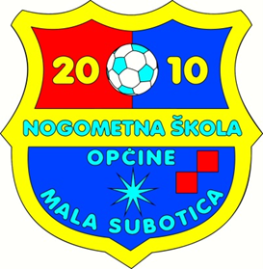

**6.LJETNI NOGOMETNI KAMP**

**NŠO MALA SUBOTICA 2023.**

|  |  |  |  |  |  |
| --- | --- | --- | --- | --- | --- |
| **PONEDJELJAK,3.7.** | ***18:00 – 19:30*** | sve ekipe | | | |
| **UTORAK, 4.7.** | ***18:00 - 19:15*** | U8 | U13 | U16/U19 | golmani U15/U16/U19 |
|  | ***19:30 – 20:45*** | U9 | U11 | U15 | golmani U8/U9/U11/U13 |
| **SRIJEDA. 5.7.** | ***18:00 – 19:15*** | U8 | U13 | U16/U19 | golmani U15/U16/U19 |
|  | ***19:30 – 20:45*** | U9 | U11 | U15 | golmani U8/U9/U11/U13 |
| **ČETVRTAK, 6.7.** | ***18:00 – 19:15*** | U8 | U13 | U16/U19 | golmani U15/U16/U19 |
|  | ***19:30 – 20:45*** | U9 | U11 | U15 | golmani U8/U9/U11/U13 |
| **PETAK, 7.7.** | ***18:00 – 19:00*** | U8 | U13 | U16/U19 | utakmice |
|  | ***19:00 – 20:00*** | U9 | U11 | U15 | utakmice |

**U8 = 2016.g i mlađi - trener Tomislav Podgorelec**

**U9 = 2015.g - trener Tomislav Podgorelec**

**U11 = 2013., 2014.g - trener Neven Kreslin**

**U13 = 2011., 2012.g - trener Neven Kreslin**

**U15 = 2009., 2010.g - trener Stjepan Makar**

**U16/U19 = 2005., 2006., 2007., 2008.g - trener Stjepan Makar**

**golmani U8/U9/U11/U13 - trener Petar Božek**

**golmani U15/U16/U19 - trener Nikola Kolar**